Descendants of Thomas Kidd of Askamore and Suzanna Poole
Information from Sue Kidd of Kansas
Thomas, John, Samuel, Charles, James Edward, James Randolph
His son John came to Headley’s Corners (near Columbus Ohio) via Canada in 1831. See appendix 2 on the Askamore page. Successive generations lived on the farm until well into the 20th Century.
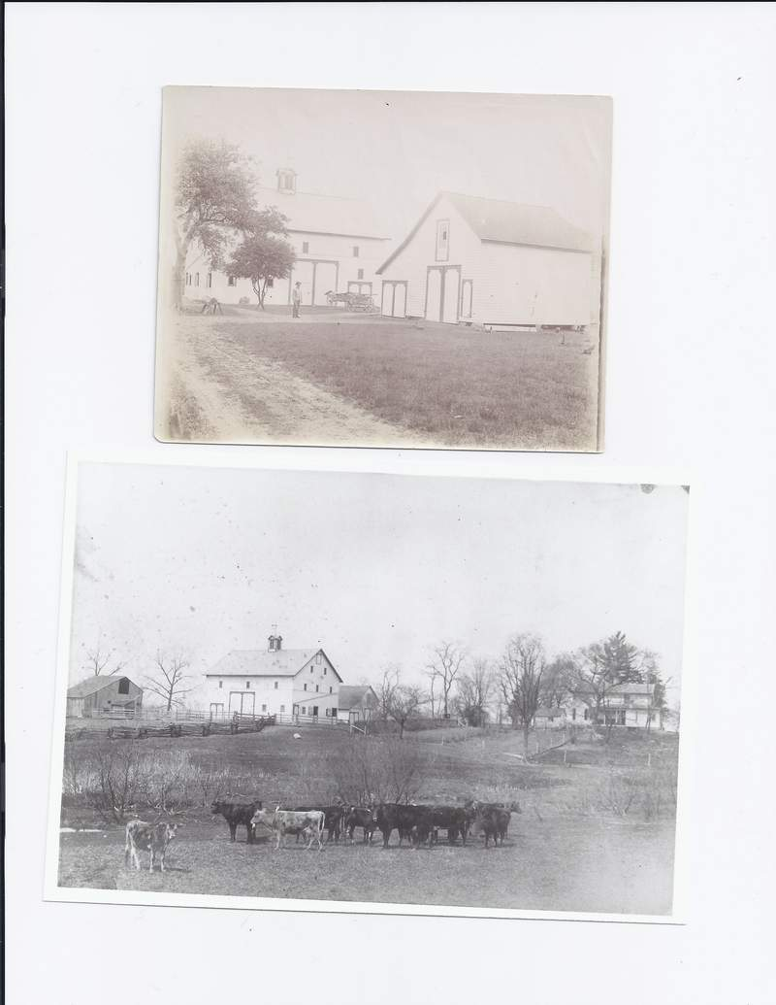
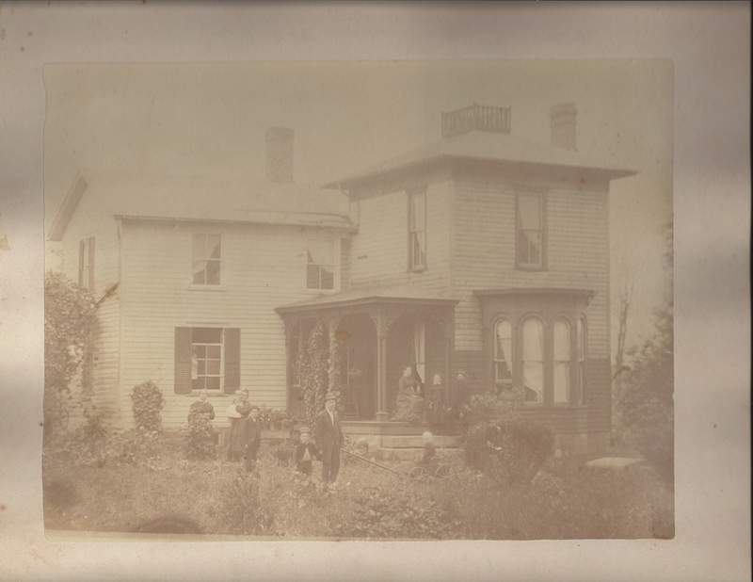
The house c 1879. The three boys are l-r Arthur, Herb (standing with Samuel 1835 – 1901) and Robert in the wagon. Samuel’s wife Sarah is seen holding the baby (likely Martha)

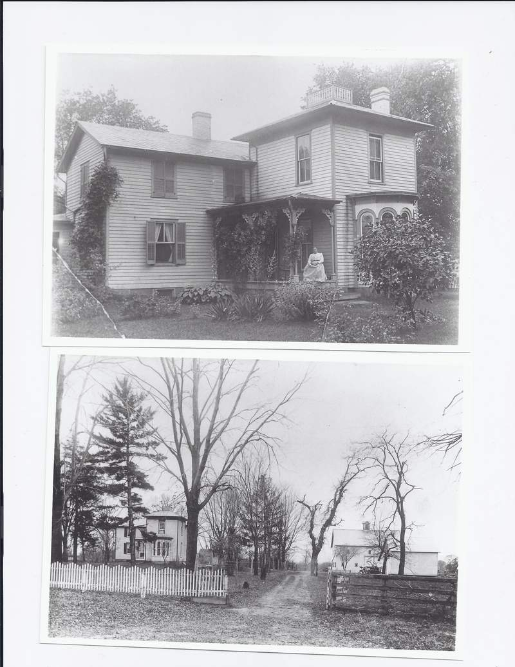
Samuel’s wife Sarah Lyon Kidd is seen on the porch.

An interesting letter written in 1867 by Olivia Kidd King thought to be a daughter of Thomas son of John who was first cousin to Samuel. Her reflections about the Civil War are very interesting. A copy of the letter is given afterwards.
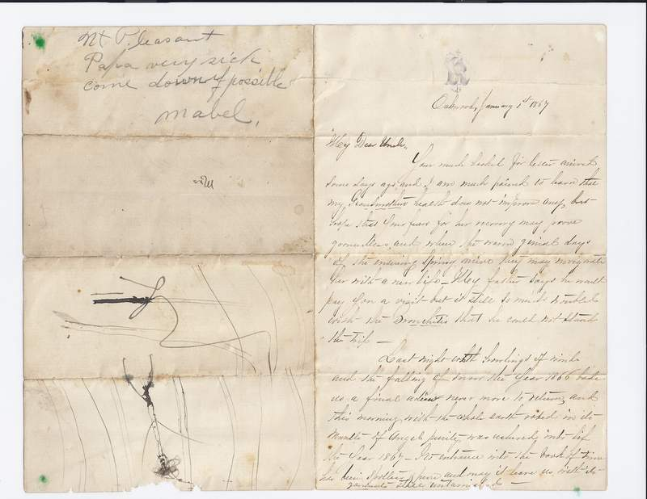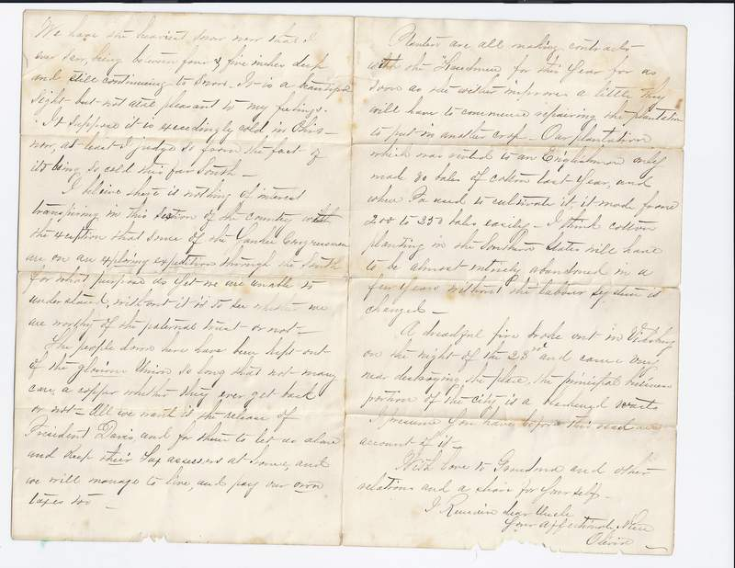

Oakwood January 1 1867
My Dear Uncle
Your much looked for letter arrived some days ago, and I am much pained to learn that my grandmother’s health does not improve any, but hope that your fears for her recovery may prove groundless and when the warm genial days of the ensuing Spring arrive, they may invigorate her with a new life. My father says that he will pay for a visit but is still so …..with the bronchitis that he could not stand the trip.
Last night with howling of winds and the falling of snow the year the year 1866 bade us a final adieu never more to return, and this morning with the whole earth robed in its mantle of angel purity was ushered into life the year 1867. Its entrance into the book of time has been spotless& pure and may it leave us with its garments still untarnished.
We have the heaviest snow now that I have ever seen being between four & five inches deep and still continuing to snow. It is a beautiful sight but not at all pleasant to my feelings. I suppose that it is exceedingly cold in Ohio now at least I judge so from the fact of its being so cold so far south.
I believe that there is nothing of interest transpiring in this section of the country with the exception that the Yankee Congressmen are on an exploring expedition through the south for what purpose as yet we are unable to understand, without it is to see whether we are worthy of the paternal trust- or not-
The people down here have been kept out of the glorious Union so long that not many care a copper whether they ever get back or not- All we want is the release of President Davis, and for them to let us alone and keep their tax assessment at home, and we will manage to live and pay our own taxes too.
Planters are all making contracts with the Freedmen for this year for as soon as the weather improves a little they will have to commence repairing the plantation to put in another crop. Our plantation which was rented to an Englishman only made 80 bales of cotton last year and when Pa used to cultivate it, it made from 200 to 250 bales easily. I think that cotton planting in the southern states will have to be almost entirely abandoned in a few years without the labour system is changed.
A dreadful fire broke out in Vicksburg on the night of the 23rd and came very near destroying the place, the principal portion of the city is a blackened waste. I presume that before this you have read an account of it.
With love to Grandma and other relatives and a share for yourself-
I remain dear uncle
Your affectionate niece
Olivia

Two Letters of Recommendation carried by John Kidd when he travelled to the ‘new world’ in 1830. The first is signed by the Curate of Carnew

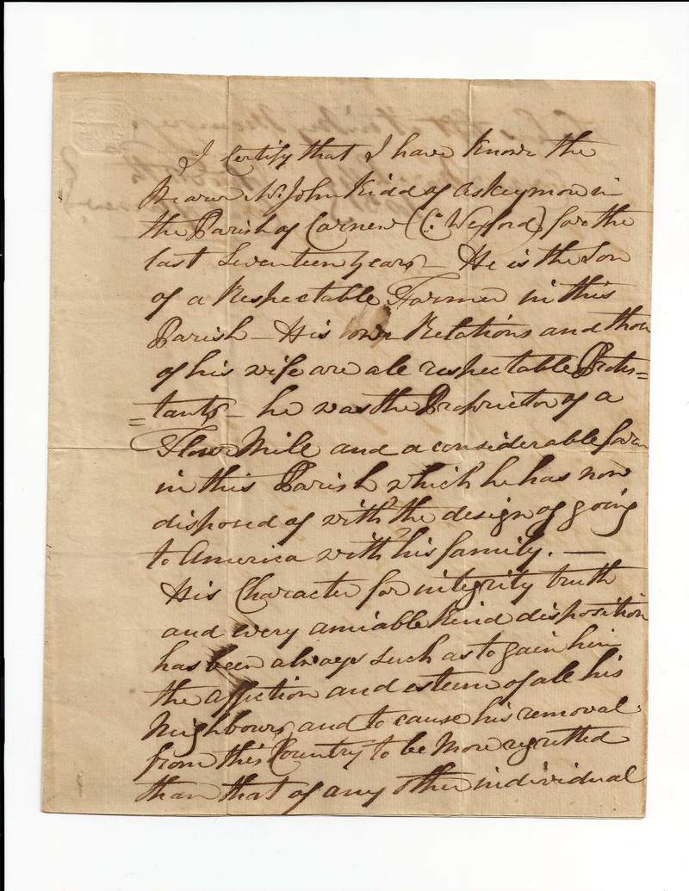

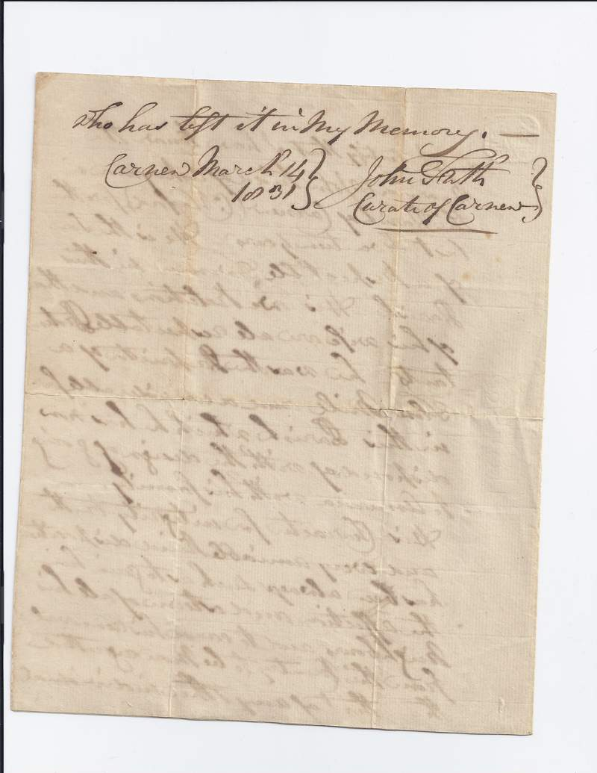

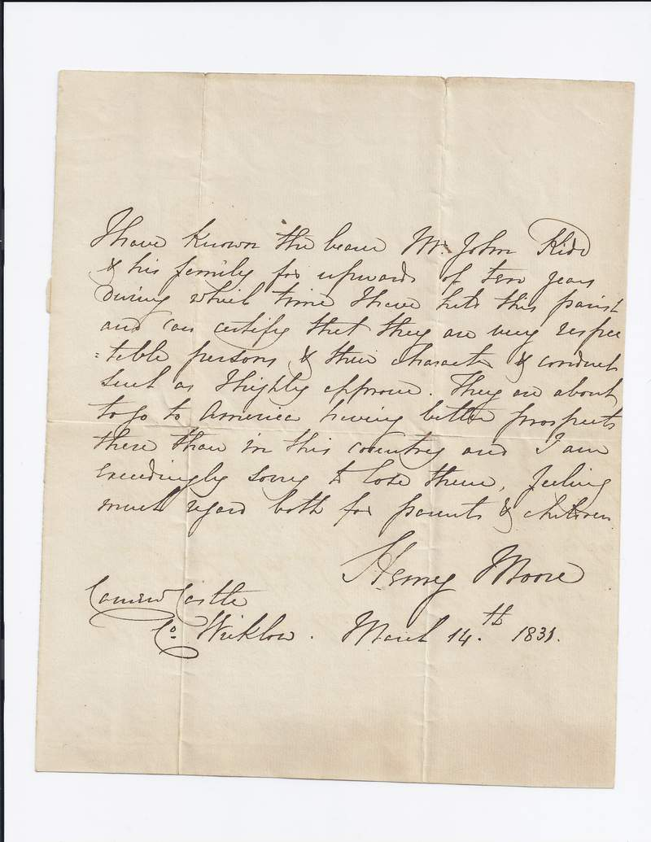

Picture of Samuel Kidd 1835 -1901 (Thomas, John, Samuel)
