Contributed by S. Jones

I have a scrap of information to add to a document that I found online regarding the Kidd family. On page 89 here:

https://www.kiddgenealogy.net/html/documents/FranklinKidd_SIrishKidds_ms1973f_Corbally85-102.pdf

it says...finally a Thomas Kidd, Gent. Farmer of Stradbally Hill, father of Agnes Kidd...who married a Thomas Willy in 1845". His name was in fact Thomas WILLS and he was my 2nd great grandfather. Thomas Wills, b. 14 March 1824 in Kilkenny Ireland, died 5 May 1896 in Hastings, Ontario. I have much more information on him in my public Ancestry tree and would be pleased to share it, as well as to have any information you might have on Agnes' father Thomas Kidd. Thomas Wills and Agnes Kidd Wills emigrated to Canada in 1862, settling in Belleville, Ontario. Thomas Wills who married Agnes Kidd was the son of Robert Wills 1798-1864.

Here is the marriage certificate between Agnes Kidd and Thomas Wills, from September 1845.
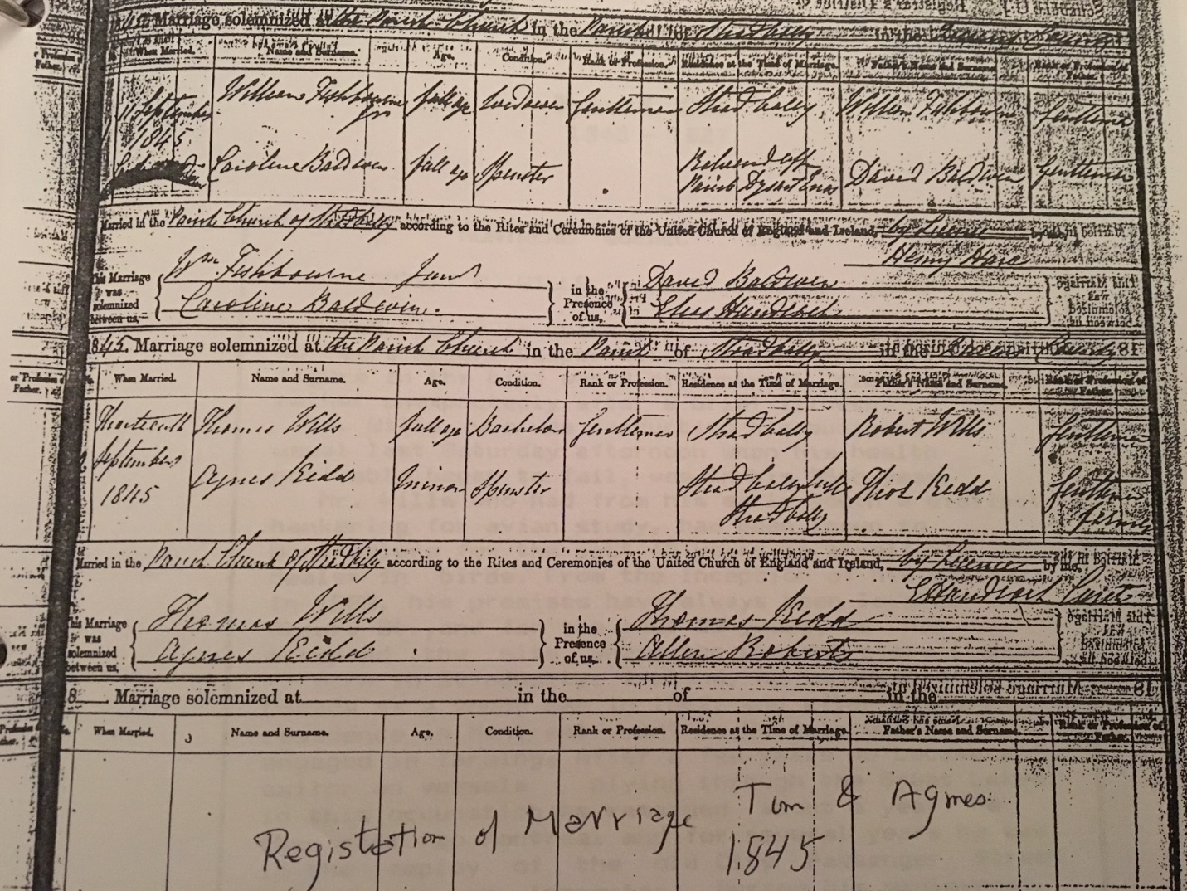

On the 1891 Canadian Census Agnes states that both her mother and father were born in Scotland. On the 1881 Canadian census she puts her own birthplace as Ireland but her Origin as “Scotch”. She puts her religion as Methodist while her husband is Church of England.
Agnes and Thomas Wills
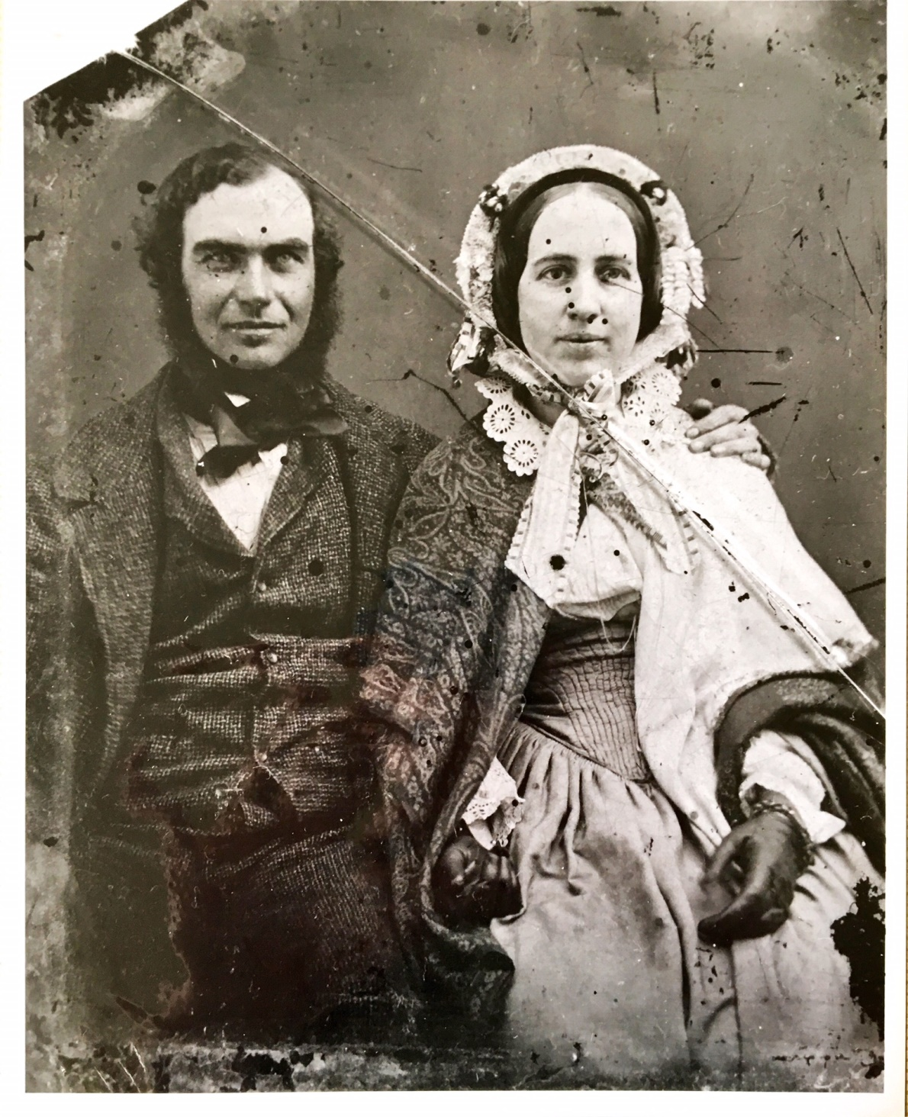
On the 1891 Canadian Census Agnes states that both her mother and father were born in Scotland. On the 1881 Canadian census she puts her own birthplace as Ireland but her Origin as “Scotch”. She puts her religion as Methodist while her husband is Church of England.
Robert Casper Wills was the eldest child of Agnes Kidd and Thomas Wills, he was born 1847 at the Wills home in Timahoe, Queen’s County, Ireland – the property that later Thomas & Agnes lost in the Wills v Wills lawsuit which caused them to emigrate to Canada in 1862. Robert was one of the 8 children that emigrated to Canada with parents Thomas and Agnes, and he became a dealer of exotic birds on Bleury Street in Montreal.

Here is where Thomas Kidd comes in. Attached is a photo of the record that shows that in 1881, Robert Casper Wills was living in Montreal with his wife Sarah, with two of Sarah’s sisters, Robert & Sarah’s daughter Ida and with a Thomas Kidd age 63. Thomas Kidd is widowed, born ca 1818, in Ireland, he is Church of England, says he was born in Ireland (as Agnes did), says his nationality is “Scotch” (Agnes said same on her census form), occupation “Gentleman”. He can’t be Agnes’ father because he was born 1818 and she was born 1827 so he’s only 9 years older than her. He is most likely her brother.

